Hallway Storage

Storage in the Hallway
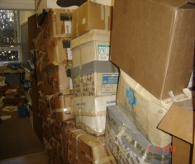
The storage of items in corridors or hallways is not permitted. When items are stored in these spaces they provide a potential hazard in the event of an emergency where occupants are attempting to exit the building.
To maintain hallways as a safe means of egress from buildings at the University, hallways must remain free of all materials that could hinder the evacuation of a building, impede the actions of emergency agencies in the event of a fire or other emergency, or are combustible and could create smoke.

Colloquium
Common gathering areas, colloquiums, were built in the hallway of each floor of the ISC. In addition to these areas being utilized for group discussions, these spaces are used as student lounges.
Although, food and drink are prohibited in the laboratories, The College of William and Mary has adopted a liberal food and beverage policy, that allows faculty, staff and students to utilize the colloquium for such items. In addition, food use only appliances, such as microwaves and refrigerators are permitted in these areas.
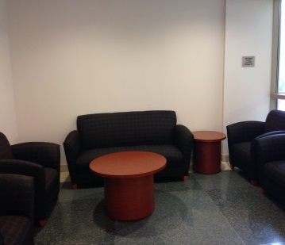
Safety and Housekeeping Practices
Due to the location of the hallway lounge areas, optimal safety and housekeeping practices should be implemented. In accordance with William and Mary Campus Fire Prevention, employ the following checklist:
- Do not accumulate combustible materials (i.e. boxes, and paper)
- Do not obstruct exits and fire doors, fire alarm stations, fire extinguishers
- Ensure appliances and their cords are in good condition (not frayed, not exposed wires)
- Ensure no multi-plug adapters are in use
- Ensure there are no extension cords in use
- Practice proper housekeeping techniques; no accumulation of burnable trash in hallways
- Ensure exit doors to laboratory and walk paths in hallways are not blocked.
- Ensure tables, appliances, equipment, book bags and personal items do not obstruct hallways or passageways.

http://www.wm.edu/offices/facilities/services/safety/firesafety/index
http://www.wm.edu/offices/facilities/services/safety/firesafety/faqs

